**JENKINS WITH GRADLE-TOOL**

Gradle is an open-source build automation tool that is used to automate the process of building, testing, and deploying software projects. It's particularly popular in the Java and Android development communities, but it can be used for a variety of programming languages and project types.

Build Script: A Gradle build script is a text file that defines various aspects of the project's build process. This includes tasks to be executed, dependencies, plugins, and more. Build scripts are written in a declarative manner, specifying what needs to be done rather than how to do it.

Tasks: In Gradle, a task is a unit of work that can be executed. Examples of tasks include compiling source code, running tests, packaging artifacts, and deploying software. You can define your own custom tasks or use built-in tasks provided by plugins.

Dependencies: Gradle allows you to define dependencies on external libraries or modules. It can automatically download and manage these dependencies, ensuring that the required components are available during the build process.

Plugins: Plugins extend Gradle's functionality to support specific project types or tasks. For example, there are plugins for Java, Android, web development, and more. Plugins provide predefined tasks and configurations that make it easier to set up and manage complex projects.

STEP1: Connect to AWS account-🡪 launch one EC2 instance

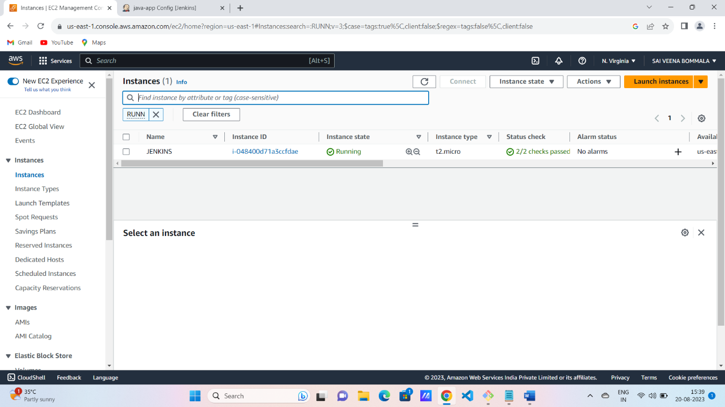

Step2: Connect to Jenkins server and setup the Jenkins install process

1 sudo amazon-linux-extras install java-openjdk11 -y

2 sudo wget -O /etc/yum.repos.d/jenkins.repo https://pkg.jenkins.io/redhat-stable/jenkins.repo

3 sudo rpm --import https://pkg.jenkins.io/redhat-stable/jenkins.io-2023.key

4 yum install jenkins -y

5 yum install git -y

6 systemctl restart jenkins

7 systemctl status jenkins

8 yum install java-1.8.0-openjdk -y

9 yum install maven -y

10 mvn --version

Step4: Now , create the pipeline job for Jenkins SharedLibrary

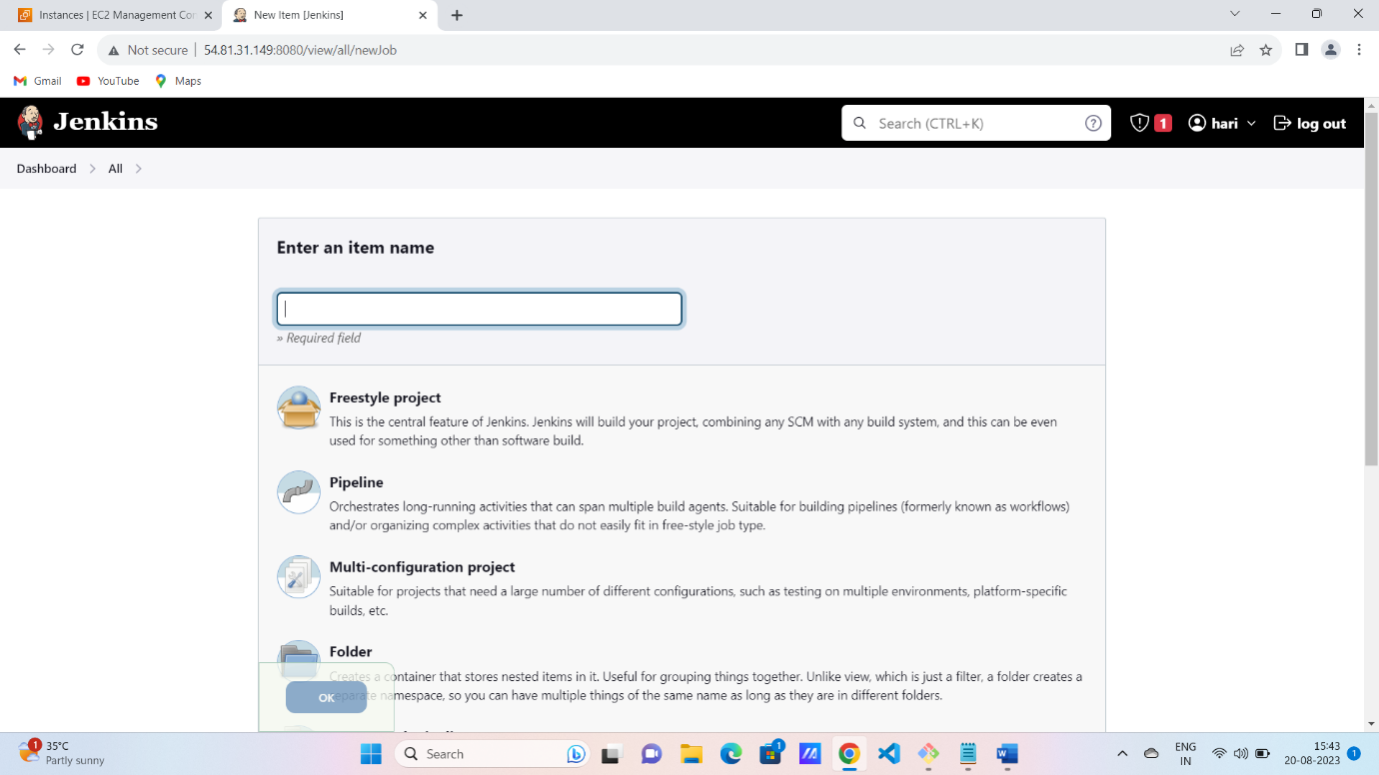

**Step5:** Now we can install the Gradle tool in Jenkins server

**Step6:** manage Jenkins-🡪 tools🡪 Gradle

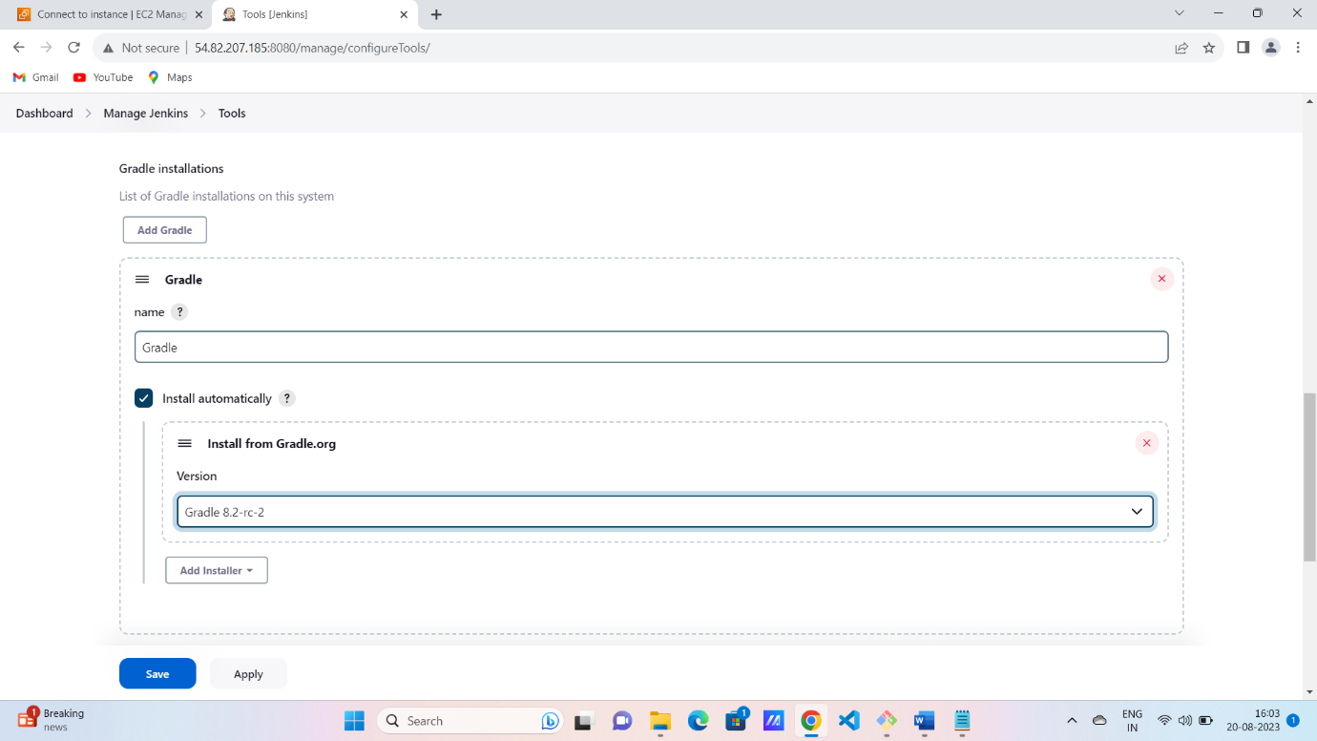

Step7: now we can create the Gradle job

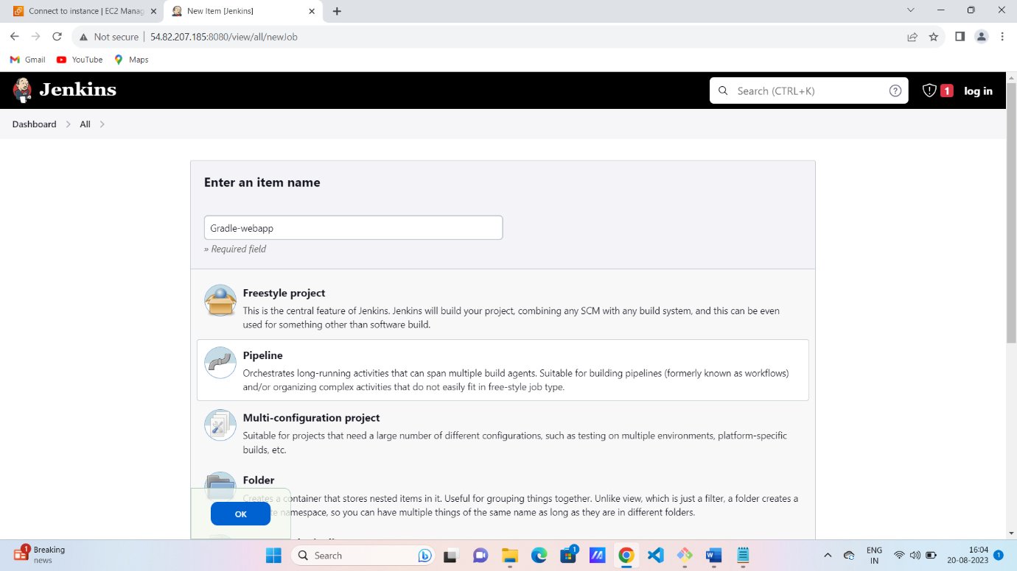

Step8: we can create the pipeline script for Gradle applications

pipeline{

agent any

tools{

gradle "Gradle"

}

stages{

stage('checkout from scm'){

steps{

git 'https://github.com/Milky19/simple-gradle-java-app.git'

}

}

stage('Build app'){

steps{

sh 'gradle clean build'

}

}

stage('Test gradle app'){

steps{

sh 'gradle test'

}

}

}

}

